Asheville Amblers
PO Box 18957
Asheville, NC 28814
www.amblers.homestead.com

First Class Mail
Address orrection requested

ASHEVILLE AMBLERS
AVA-046
Invite you to

AN APRIL EXACTA
HORSES AND NATURE

SE22/1429 – FENCE, TRYON, NC
SE22/1428 – TIEC, MILL SPRING, NC

April 23-24, 2022

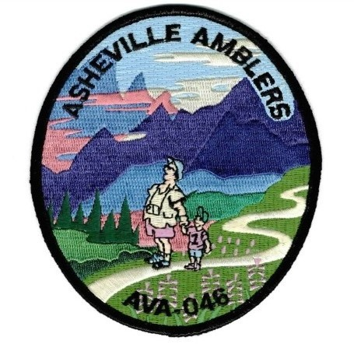

Date: Sat-Sun, April 23-24

Registration Point: FENCE
3381 Hunting Country Rd
Tryon, NC 28762

Registration Check-In Times: Sat/Sun 9 AM to 1 PM. Off the trail by 4 PM

Comments: This multi event weekend consists of 2 walks. Registration for both walks at FENCE. Walking directions for both walks and driving directions to TIEC start point provided at registration. Walks are available both days and can be walked in any order.

Fence (http://www.fence.org/)
TIEC (https://tryon.com/allevents)

Trail: Foothills Equestrian Nature Center (FENCE). 5/10 KM rated 3B. Greet Spring with its budding trees and flowers along forest trails. Walk includes 1940’s country home of Jack Kimberly of Kimberly-Clark Paper Company, then passes old log cabin schoolhouse behind flower/herb garden to totem pole carving area. At pond, the marsh boardwalk will provide fascinating views of native birds and plants. 10 KM adds NC/SC border crossing and strolls around the Tyron Block House, an equestrian center with steeplechase track and 3 show rings for dressage (horses trained on unique performances) and views of the stable area. Both options include portions of the Palmetto Trail. Walk is in Polk County for Tarheel 100. Special programs – Border Crossing.

Trail: Tryon International Equestrian Center (TIEC). 5/10 KM rated 2A (stairs). TIEC was opened in 2014 and has hosted national and international equestrian competitions and events every year since. You will have overview from several levels of the International Stadium with its expansive show area and Tryon Stadium where most of the national competitions are held. You’ll also tour through the Tryon Resort Promenade with its fancy shops and amenities to serve the “horsey” set and the Legend Plaza with its hand painted Venetian carousal which is free to ride. Plaza also includes more affordable places to eat and drink. You’ll also tour the 4 ring areas where smaller events and training sessions are held. Finally, you will tour the stable area where these magnificent animals are housed before and after events.

Trail Notes: Restrooms available at or near start points plus scattered along the trails. Trail shoes and poles recommended for FENCE. Sneakers OK for TIEC. No pets. Always carry water and a snack.

Fees and Awards: IVV credit is $3. IVV credit for children 15 and under is free. Free walkers welcome. DONATIONS WELCOME.

Specialties: IVV books, club memorabilia, “B” awards and club shirts available.
Procedure: All participants must complete a Start Card at Registration Point. Card is carried on walk and returned when done. This applies even if you are a free walker. An adult must accompany all children under 16. All Start Cards remain the property of the Asheville Amblers.
Stipulations: Event proceeds rain or shine. NO REFUNDS.
Disclaimer: The sponsors are not responsible for accidents, theft, and/or material damage. Every effort has been made to make these safe, enjoyable and memorable events.

What is a Volkswalk: A non-competitive walk, typically 10KM (6.2 miles) long through an historic or scenic area. It is designed to promote fun, fitness and friendship. American GIs brought it from Germany in the 1960s.

Directions: FENCE, 3381 Hunting Country Rd. Tryon, NC. From I-26, take SC Exit 1 toward Landrum. From west, turn tight off ramp, and from east turn left. Go approx ½ mile and just past Ingles, turn right on High Farm Rd. Go 0.6 miles to stop sign at “T”. Right on Prince and go ½ mile to Hunting Country Rd. Left on Hunting Country and go 0.6 miles passing under Interstate to FENCE Center sign. Right into FENCE and immediate right to pavilion for parking and registration.

For More Information
Contact: Dennis Michele
828-708-3643
E-mail: dmichblue@aol.com

Updates at https://www.ashevilleamblers.com/

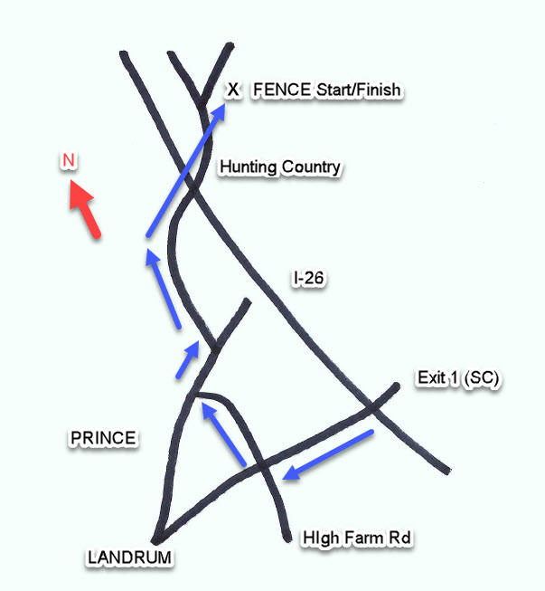

Special thanks to Tracie Hanson, Operations Manager at FENCE, for her assistance with this walk.

